TITLE OF ARTICLE IN ENGLISH/ TITLE OF ARTICLE IN ENGLISH/ TITLE OF ARTICLE IN ENGLISH/

Jan KOWALSKI, Milan KOZAK

Introduction

The introduction should include analysis of present conditions and the goal of the work. Figures, photos and tables – have to be included in the text of the paper with appropriate numbering and description. Equations must be written in a clear manner, with large enough font to be readable. All units should be SI units.

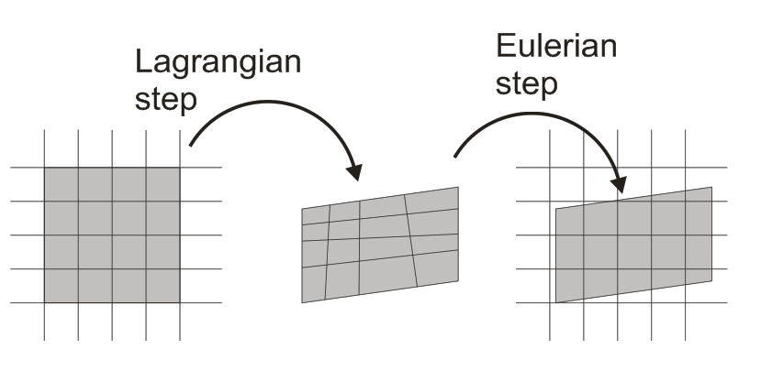
Fig. 1. Split operator

Experimental procedure

A description of experimental methods and used sources should be included here. Figures, photos and tables – have to be included in the text of the paper with appropriate numbering and description (descriptions should be in English). Equations must be written in a clear manner, with large enough font to be readable. All units should be SI units.

Tab.1. Selected properties of materials
Material | Chemical composition [%] | Yield stress  [MPa] | Young’s modulus  [MPa] | Poisson’s ratio | Brinell Hardness HB
Lead | 99,98 Pb; 0,05 Ag; 0,05As; 0,01Sb; 0,05Sn; 0,05Cu; 0,05Fe; 0,05Zn; 1,0Bi | 5 | 14000 | 0,43 | 4,4
Aluminum 1050 | 99,5 Al; 0,4Fe; 0,3Si; 0,05Cu; 0,07Zn; 0,05Ti | 26 | 70000 | 0,33 | 22,4

Results and discussion

Results should be presented and discussed in this section. Figures, photos and tables – have to be included into the text of the paper with appropriate numbering and description (descriptions should be in English). Equations must be written in a clear manner, with large enough font to be readable. All units should be SI units.

Conclusions

Conclusions/ Conclusions/ Conclusions/ Conclusions/ Conclusions/ Conclusions/ Conclusions/ Conclusions/ Conclusions/ Conclusions/ Conclusions/ Conclusions.

References

- Banabic D., Bunge H-J., Pöhlandt K., Tekkaya A.E.: Formability of metallic materials, Springer, Berlin 2000.
- Hill R.: On discontinuous plastic states, with special reference to localized necking in thin sheets, J. Mech. Phys. Sol., 1, 1952, p. 19-30.
- Ghosh A.K.: Plastic flow properties in relation to localized necking in sheets. In: Mechanics of Sheet Metal Forming, Plenum Press, New York 1978.

jkowal@prz.edu.pl, Rzeszow University of Technology, Al. Powstańców Warszawy 8, 35-959 Rzeszów, Poland
mkoza@tuke.sk, Technical University in Košice, Mäsiarska 74, 040 01 Košice, Slovakia

